  API Project (Project Name)

*Group Name:*

How I Met Your Code

*Members:*

Rajiv Jagirdar

William Collins

Fred Talai

Nicholas Antonyan

Louis McGruder

*Project Description:*

Search for any movie title and see details about the movie (Title, Rating, Release Date, Cast and Poster) and it would link to NY Times Movie Reviews to get their review, and we could link it to the cast name to see what else is being said about them.   It will also let you search with your zip code to see near movie theaters and showtimes using Fandango. Fandango may allow us to use Rotten Tomatoes, so we could incorporate that as well.

*Sketch of Final Product:*

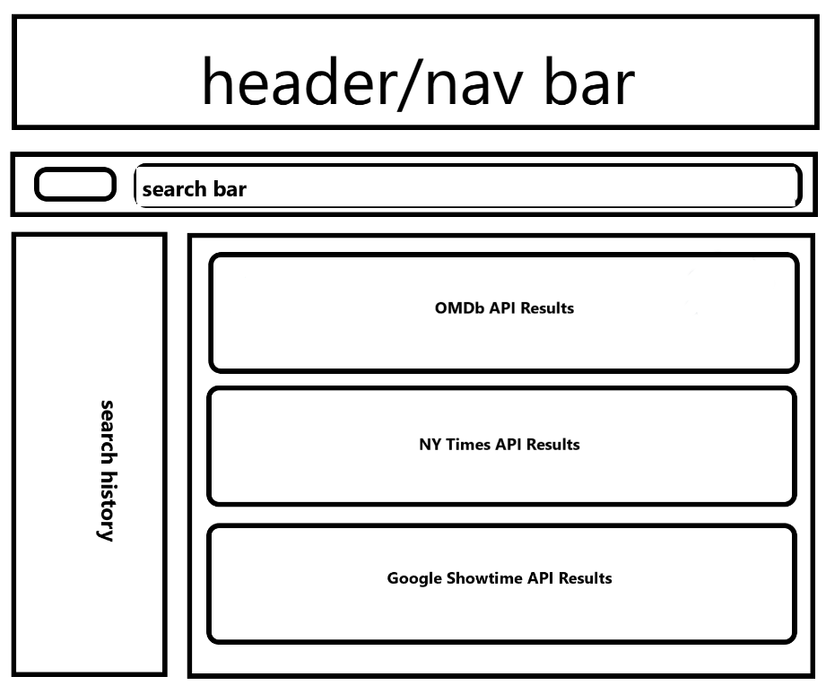

*API’s to be Used:*

* Open Movie Database - key: 45885583
* NY Times Movie Reviews - key: ce7b9c363002463cb0f66eff0dfe284f
* Fandango -  key: 54vy8g2d29xs2pqpf95urry9

*Breakdown of Tasks:*

* create wireframe (assign as group on Wed 10/3)
  + send out tasks to group members that creates the basic html wireframe
    - header, searchbar/search history, 3 sections for the apis
  + send out tasks for css
  + complete by Sat 10/6
* Wed - Sat get familiar with the API’s we are using on individual level
* breakout tasks for javascript/jqeury/ajax -- pseudo code as a group on Saturday 10/6
  + start with the initial ajax calls
    - figure out the urls and the data to be pulled
  + send out tasks to group members
* regroup and debug
* make pretty